AFFIDAVIT OF IDENTITY THEFT
I, Debra Dunham being of lawful age and first duly sworn do hereby state that I am of sound mind and have experienced identity theft of true name of real property at its severest level.
- The student loans on Experian show a maturity date of Jan 2026 when in fact they were set to deferment until 2028. The total debt being reported on the actual credit report is $96,081 yet the summary says $161,113. The other bureaus have found and fixed the fraud, but Experian keeps changing the profile.
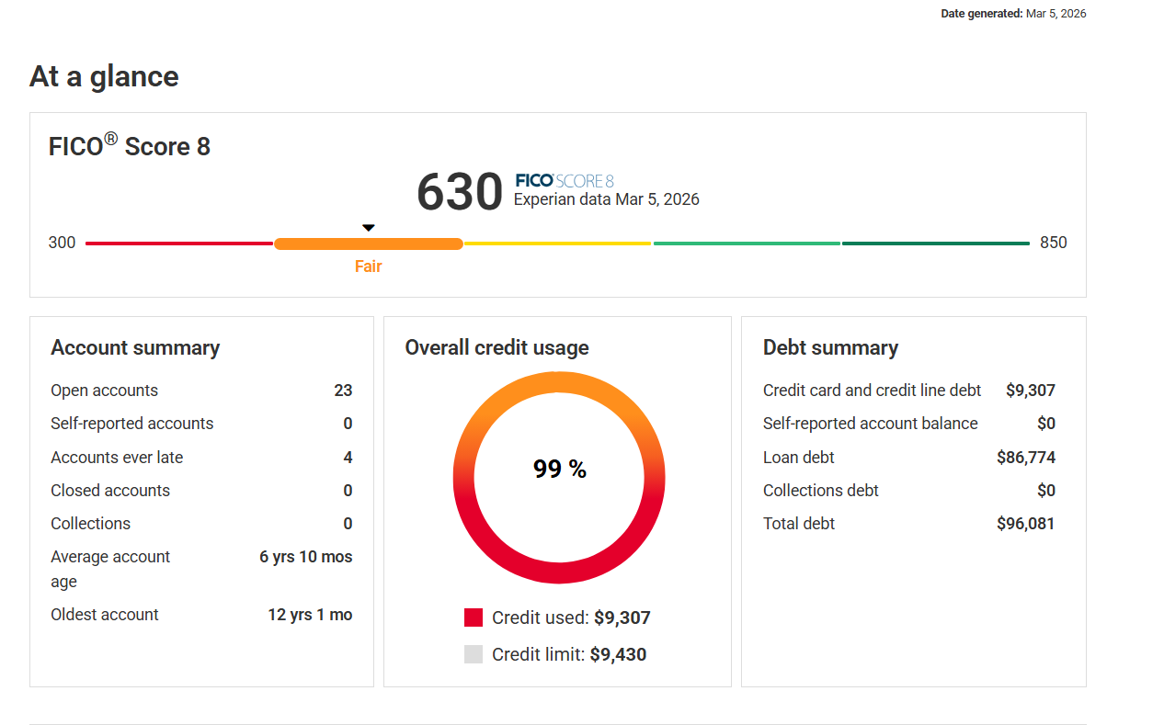
This was also closed on Equifax and Transunion but appears to be reopened with mismatching real name and SSN info but Experian has let it update and reflect the correct social security number although it was obviously re-created and updated as a new account.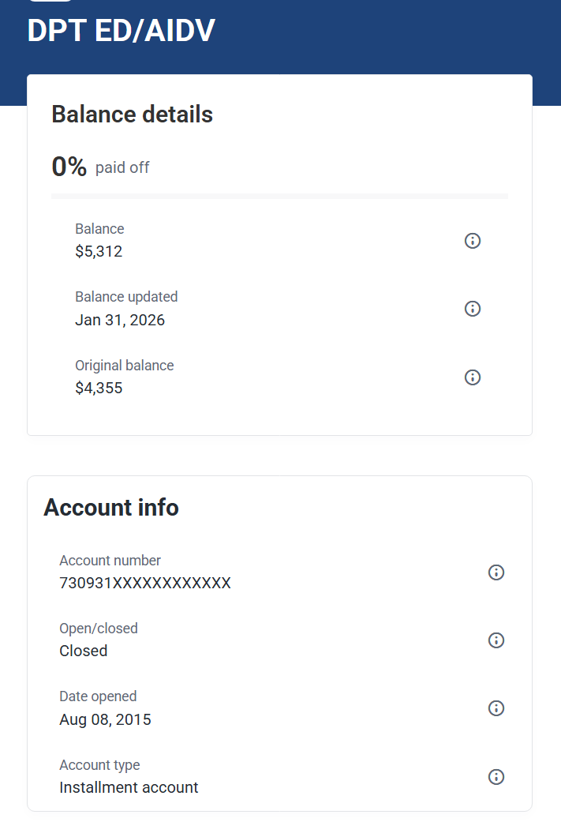

- The address on file of 1316172 NW SHERIDAN LAWTON, OK 73505 has never been reported, is invalid, and illegally attached to the report, is proof of real name identity theft and needs to be removed. With Experian’s own internal account, the address is associated with a business and is properly notated. Any obligations would report a personal residential address, especially If it is associated to any federal financial responsibilities such as a student loan which would require it to be even scrutinized even further. All addresses need to be removed as there is either no lender reporting it, or nothing financially related attached

- The name Debra Elaine Dunham has never been used to apply for or collateralize any financial obligation and is proof or real name identity theft and needs to be removed. Debra Young Dunham, Debora Young Dunham, Debra Y. Dunham are aliases, and my name should only reflect Debra E. Dunham. Debra Dunham is trying to be associated with my profile but is incorrect as well.
- All capital one accounts have mis-match real name and SSN info and are reporting inaccurate or mismatching company contact address and phone information across bureaus from the lender or none and were opened or modified fraudulently.
- The PennyMac mortgage was opened simultaneously with mis-matching real name, social security number, disclosures, and account information.
  - The payments say they started in July but do not match the mortgage from Sovereign and no payments were ever made directly to them.
  - The closing disclosures were recreated and clearly do not match what we signed at closing.
  - The welcome letter, note, and deed of trust have incorrect loan numbers, are not the original and the FHA assignment is missing. None of the instruments were in the abstract ﬁled in the county, but there is a release of lien that doesn’t have my address or name or the previous owners.
- Every inquiry is matched to the Experian credit report with a purple number highlighted in yellow and shows a timeline of residential and commercial mortgage loans and lines of credit that were attempted and the red corresponds to the mortgage theft due to Experian allowing inquiries even though my profile has been locked and frozen. None of the Transunion promotional inquiries are legitimate and each one in the report is an illegal attempt to establish credit in my name and needs to be researched, investigated, and removed.
In the example below there is Transunion inquiries that were unauthorized and caused by the Sovereign and PennyMac theft.
SOVEREIGN BANK via XACTUS LLC | 05/13/2025, 04/04/2025, 11/07/2024

- My taxes in 2022 were fraudulently filed and coincides with the date of a foreclosure which is when my credit profile began to show alerts with mismatch addresses and SSN warnings.
- The inquiries highlighted in yellow are known to be accurate. The highlighted red selections are fraudulent as it relates to this report. The dates correspond to PennyMac and Sovereign attempts to ruin my identity and take place July – December. There is proof of inquiries from Sovereign and PennyMac masquerading with different names using the wrong dates.
- PennyMac created a new account with different balance information and the same account number, and it still cannot be disputed due to the current status of my Experian profile on 3/8/2026.
- I received notification via SMS at the phone number on file even though I did not try to login and learned that it was from an unassociated profile that did not belong to me. I have not logged in since.

4.Inquires:
AFTERPAY US INC
Inquired on 06/26/2025
760 MARKET ST, SAN FRANCISCO CA 94102
(855) 289-6014
3a. ALTAIR/LENDIFY
ASSOC/LEN
Inquired on L09/25/2025
29399 US HIGHWAY 19 N STE 150, CLEARWATER FL 33761
3b. ALTAIR/LS/NATWIDFI/EVAFI
Inquired on 09/15/2025
2 CORPORATE PARK, IRVINE CA 92606
AMERICAN EXPRESS
Inquired on 05/20/2025
5301 MCCONNELL RD, WHITSETT NC 27377
(800) 874-2717
AMEX
Inquired on 05/20/2025
PO BOX 31525, SALT LAKE CITY UT 84131
(800) 874-2717
AUTO APPROVE LLC
Inquired on 07/25/2025
6200 SHINGLE CREEKPKWY STE 400, BROOKLYN CENTER MN 55430
(763) 200-4560
5. AXCSSFN/CNGO
Inquired on 09/23/2025 And 07/29/2025
7755 MONTGOMERY RD STE 400,
CINCINNATI OH 45236
(888) 296-2274
6. BEST EGG
Inquired on 07/27/2025
1523 CONCORD
PIKE STE 201, WILMINGTON DE 19803
(302) 358-2730
1f. CONSUMERINFO.COM
Inquired on 05/27/2025
475 ANTON BLVD,
COSTA MESA CA 92626
2a. CREDCO/PENNYMAC LOAN SVC
Inquired on 12/05/2025
27001 AGOURA RD,
7. CREDIT KARMA
Inquired on01/17/2026 ,01/14/2026 ,01/10/2026 ,01/07/2026 ,01/03/2026 ,12/31/2025 ,12/28/2025 ,12/24/2025 ,12/20/2025 ,12/17/2025 ,12/13/2025 ,12/10/2025 ,12/06/2025 ,12/03/2025 ,11/30/2025 ,11/26/2025 ,11/22/2025 ,11/19/2025 ,11/15/2025 ,11/12/2025 ,11/08/2025 ,11/05/2025 ,11/01/2025 ,10/29/2025 ,10/27/2025 ,10/22/2025 ,10/18/2025 ,10/15/2025 ,10/11/2025 ,10/08/2025 ,10/04/2025 ,10/01/2025 ,09/28/2025 ,09/25/2025 ,09/20/2025 ,09/17/2025 ,09/13/2025 ,09/10/2025 ,09/06/2025 ,09/03/2025 ,09/01/2025 ,08/27/2025 ,08/16/2025 ,08/14/2025 ,08/09/2025 ,08/06/2025 ,08/02/2025 ,07/30/2025 ,07/27/2025 ,07/23/2025 ,07/19/2025 ,07/16/2025 ,07/12/2025 ,07/09/2025 ,07/05/2025 ,07/02/2025 ,06/29/2025 ,06/25/2025 ,06/21/2025 ,06/18/2025 ,06/14/2025 ,06/11/2025 ,06/07/2025 ,06/04/2025 ,06/01/2025 ,05/28/2025 ,05/24/2025 ,05/21/2025 ,05/17/2025 ,05/10/2025 ,05/07/2025 ,05/03/2025 ,04/30/2025 ,04/27/2025 ,04/23/2025 ,04/19/2025 ,04/16/2025 ,04/12/2025 ,04/09/2025 ,04/05/2025 ,04/02/2025 ,03/30/2025 ,03/26/2025 ,03/22/2025 ,03/19/2025 ,03/15/2025 ,03/12/2025 ,03/08/2025 and 03/05/2025
760 MARKET ST FL 2, SAN FRANCISCO CA 94102
- CREDIT KARMA
Inquired on01/16/2026 ,01/15/2026 ,01/08/2026 ,01/07/2026 ,01/06/2026 ,01/04/2026 ,01/03/2026 ,01/01/2026 ,12/30/2025 ,12/28/2025 ,12/26/2025 ,12/24/2025 ,12/22/2025 ,12/17/2025 ,12/16/2025 ,12/11/2025 ,12/10/2025 ,12/08/2025 ,12/07/2025 ,12/06/2025 ,12/05/2025 ,12/04/2025 ,12/02/2025 ,12/01/2025 ,11/22/2025 ,11/21/2025 ,11/18/2025 ,11/16/2025 ,11/15/2025 ,11/13/2025 ,11/09/2025 ,11/08/2025 ,11/07/2025 ,11/06/2025 ,11/05/2025 ,11/04/2025 ,11/02/2025 ,11/01/2025 ,10/31/2025 ,10/23/2025 ,10/21/2025 ,10/15/2025 ,10/14/2025 ,10/09/2025 ,10/08/2025 ,10/05/2025 ,10/03/2025 ,10/02/2025 ,10/01/2025 ,09/28/2025 ,09/27/2025 ,09/22/2025 ,09/13/2025 ,09/11/2025 ,09/10/2025 ,09/09/2025 ,09/08/2025 ,09/07/2025 ,09/03/2025 ,09/01/2025 ,08/28/2025 ,08/24/2025 ,08/23/2025 ,08/22/2025 ,08/20/2025 ,08/19/2025 ,08/15/2025 ,08/12/2025 ,08/11/2025 ,08/10/2025 ,08/09/2025 ,08/08/2025 ,08/07/2025 ,08/05/2025 ,08/02/2025 ,08/01/2025 ,07/31/2025 ,07/28/2025 ,07/27/2025 ,07/16/2025 ,07/12/2025 ,07/10/2025 ,07/09/2025 ,07/06/2025 ,07/04/2025 ,07/03/2025 ,07/02/2025 ,07/01/2025 ,06/18/2025 ,06/17/2025 ,06/13/2025 ,06/12/2025 ,06/08/2025 ,06/03/2025 ,06/01/2025 ,05/31/2025 ,05/30/2025 ,05/29/2025 ,05/28/2025 ,05/25/2025 ,05/22/2025 ,05/21/2025 ,05/20/2025 ,05/19/2025 ,05/18/2025 ,05/17/2025 ,05/16/2025 ,05/15/2025 ,05/14/2025 ,05/13/2025 ,05/08/2025 ,05/04/2025 ,05/03/2025 ,05/01/2025 ,04/25/2025 ,04/21/2025 ,04/20/2025 ,04/11/2025 ,04/10/2025 ,04/07/2025 ,04/06/2025 ,04/04/2025 ,04/02/2025 ,04/01/2025 ,03/27/2025 ,03/26/2025 ,03/23/2025 ,03/19/2025 ,03/18/2025 ,03/17/2025 ,03/12/2025 ,03/09/2025 ,03/08/2025 ,03/07/2025 and 03/05/2025
760 MARKET STFL 2,SAN FRANCISCOCA 94102(415) 510-5272

2. CREDIT KARMAINC
Inquired on12/05/2025 and 05/12/2025
760 MARKET STFL 2, SAN FRANCISCO CA 94102
1e. EXPERIAN
Inquired on03/03/2026 ,03/02/2026 ,02/28/2026 ,02/26/2026 ,02/25/2026 ,02/23/2026 ,02/22/2026 ,02/21/2026 ,02/07/2026 ,02/06/2026 ,02/02/2026 ,02/01/2026 ,01/31/2026 ,01/28/2026 ,01/24/2026 ,01/18/2026 ,01/17/2026 ,01/10/2026 ,01/03/2026 ,12/27/2025 ,12/20/2025 ,12/13/2025 ,12/06/2025 ,12/03/2025 ,11/29/2025 ,11/22/2025 ,11/15/2025 ,11/08/2025 ,11/01/2025 ,10/25/2025 ,10/18/2025 ,10/11/2025 ,10/04/2025 ,09/27/2025 ,09/20/2025 ,09/13/2025 ,09/06/2025 ,08/30/2025 ,08/23/2025 ,08/09/2025 ,07/30/2025 ,07/27/2025 ,07/26/2025 ,07/19/2025 ,07/15/2025 ,07/12/2025 ,07/05/2025 ,06/28/2025 ,06/21/2025 ,06/14/2025 ,06/07/2025 ,05/31/2025 ,05/24/2025 ,05/17/2025 ,05/10/2025 ,05/03/2025 ,04/20/2025 ,04/19/2025 ,04/05/2025 ,03/22/2025 and 03/08/2025
475 ANTON BLVD,COSTA MESA CA92626 (866) 431-3471

10a. EXPERIAN
Inquired on 03/02/2026 ,02/28/2026 ,02/26/2026 ,02/25/2026 ,02/23/2026 ,02/22/2026 and 02/01/2026 PO BOX 9600, ALLEN TX 75013 (800) 311-4769 CAPS APIDISCLOSURE

10. EXPERIAN
Inquired on 02/27/2026 ,01/22/2026 ,01/06/2026 ,12/24/2025 ,12/05/2025 ,11/21/2025 ,11/15/2025 ,11/06/2025 ,10/23/2025 ,10/21/2025 ,10/02/2025 ,09/27/2025 ,08/28/2025 ,08/21/2025 ,08/18/2025 ,08/02/2025 ,08/01/2025 ,07/15/2025 ,07/09/2025 ,06/17/2025 ,05/29/2025 ,05/20/2025 ,05/08/2025 ,03/26/2025 and 03/07/2025
475 ANTON BLVD, COSTA MESA CA 92626

1c. EXPERIAN
Inquired on 05/27/2025
475 ANTON BLVD, COSTA MESA CA 92626

1a. EXPERIAN
Inquired on 05/27/2025
PO BOX 9600, ALLEN TX 75013 (800) 311-4769

1b. EXPERIAN CREDITMATCH
Inquired on03/03/2026 ,03/02/2026 ,02/28/2026 ,02/26/2026 ,02/25/2026 ,02/23/2026 ,02/22/2026 ,02/06/2026 ,02/02/2026 ,02/01/2026 ,01/28/2026 ,01/18/2026 ,12/03/2025 ,07/30/2025 ,07/27/2025 ,07/15/2025 and 04/20/2025
475 ANTON BLVD # D4, COSTA MESA CA92626

1d. FLEETFINANCIAL LLC
Inquired on 07/30/20257257 S TUCSONWAY FL 2, ENGLEWOOD CO 80112 (866) 683-5505

LN/DATALAB/PROGRESSIVE
Inquired on08/07/2025 and 06/12/2025
6300 WILSON MILLS RD, MAYFIELD VILLAGE OH 44143

8.MARLETTESERVICING LLC
Inquired on 07/29/2025 3419 SILVERSIDE RD, WILMINGTON DE19810

11. NCINO/FORTSILL
Inquired on 01/21/2026 1614 NW 67TH ST, LAWTON OK 73505 (580) 353-2124

9b. REPRISEFINANCIAL/WEBBAN
Inquired on 07/27/2025PO BOX 143454, IRVING TX 75014(855) 475-6767

9a. SOFI BANK NA
Inquired on 11/05/2025
2750 E COTTONWOOD PKWY, COTTONWOOD HEIGHTS UT 84121
(855) 456-7634

9. SOFI BANK NA
Inquired on 07/27/2025
2750 E COTTONWOOD PKWY, COTTONWOOD HEIGHTS UT 84121
(855) 456-7634
1.XACTUSAVANTUS
Inquired on 05/13/2025
600 SAW MIL LRD, WEST HAVEN CT 06516
(203) 931-2000
On behalf of SOVEREIGN BANK

Transunion Promotional Inquiries all of which should be deleted:
UPSTART NETWORK INC | 01/27/2026, 12/02/2025, 11/04/2025
CB/CCI | 01/22/2026, 01/02/2026, 12/09/2025, 11/19/2025, 10/31/2025, 10/14/2025, 09/25/2025, 09/05/2025, 08/15/2025
AVANT LLC | 01/13/2026, 12/09/2025, 11/11/2025, 06/10/2025, 05/13/2025, 04/08/2025
SPARROW INC | 12/31/2025
FIRST PREMIER | 12/11/2025
KUBER FINANCIAL | 12/10/2025, 11/10/2025, 08/21/2025, 07/05/2025, 05/31/2025, 04/03/2025
CARIBOU | 12/07/2025
MERRICK BANK | 12/06/2025, 11/01/2025, 10/06/2025, 09/09/2025, 08/11/2025, 07/08/2025, 06/09/2025, 05/07/2025
CSTLCOMUNITYTPRSPER | 12/01/2025, 11/01/2025, 10/01/2025, 09/04/2025, 08/01/2025, 07/01/2025
MARINER FINANCE | 11/18/2025, 09/23/2025, 07/22/2025
CCB/AXCESS | 11/03/2025, 09/09/2025, 07/14/2025
DOLLAR FINANCIAL DBA CENTZ | 10/29/2025, 08/09/2025, 06/24/2025, 04/24/2025
MISSION LANE WEBBBANK | 10/24/2025
TRUE AUTO PROTECTION | 10/21/2025, 09/23/2025
BRUNDAGE MANAGEMENT | 10/15/2025, 08/06/2025
ONE CAPITAL LENDING | 09/11/2025
MUTUAL OF OMAHA | 09/01/2025, 07/01/2025, 04/26/2025
PROGRESSIVE INSURANCE | 08/19/2025, 07/22/2025, 06/24/2025, 04/22/2025
CB INDIGO | 07/28/2025, 07/09/2025, 06/12/2025, 05/23/2025, 05/06/2025

On transunion:
11. CREDITWISE CAPITAL1 TU-C | 03/13/2026
Location
CAPITAL ONE
PO BOX 30285
PO BOX 85870
SALT LAKE CITY, UT 84130
Phone (800) 227-4825
10. TRANSUNION CONSUMER INTE | 03/13/2026
Location
760 MARKET STREET 10TH FLOOR
SAN FRANCISCO, CA 94102
Phone(844) 5

9. CAPITAL ONE | 03/12/2026
Location
P O Box 31293
Salt Lake City, UT 8431
Phone (800) 955-7070
8. TRANSUNION CONSUMER INTE | 03/09/2026
Location
100 CROSS STREET
SAN LUIS OBISP, CA 93401
7. FB&T/CRDTSHOP | 03/01/2026
Location
221 W 6TH ST
SUITE 825
AUSTIN, TX 78701
Phone(800) 317-9240
6a. DEBRA DUNHAM via CREDITWISE CAPITAL1 TU-A | 03/14/2026, 03/09/2026, 03/08/2026, 03/06/2026, 03/05/2026, 03/03/2026,  02/22/2026, 02/18/2026, 02/15/2026, 02/09/2026, 01/28/2026, 01/26/2026,  01/20/2026, 01/12/2026,  01/06/2026, 12/27/2025, 12/20/2025, 12/13/2025, 12/07/2025, 12/06/2025,  12/04/2025, 12/03/2025, 11/23/2025, 11/16/2025, 11/15/2025, 11/14/2025,  11/10/2025, 11/08/2025, 11/04/2025, 10/26/2025, 10/23/2025, 10/18/2025, 10/09/2025, 10/07/2025,  10/05/2025, 10/04/2025, 09/28/2025, 09/27/2025,  09/23/2025, 09/16/2025, 09/13/2025, 09/12/2025, 09/06/2025, 09/04/2025, 08/31/2025, 08/23/2025, 08/11/2025, 08/10/2025, 08/07/2025, 08/03/2025, 07/31/2025, 07/27/2025, 07/24/2025, 07/10/2025, 07/08/2025, 07/06/2025, 06/16/2025, 06/12/2025, 06/10/2025, 05/27/2025, 05/16/2025, 04/19/2025, 04/15/2025, 04/01/2025, 03/06/2025, 02/06/2025, 01/08/2025, 12/11/2024, 11/14/2024, 10/16/2024, 09/19/2024, 08/21/2024, 07/25/2024, 07/22/2024, 07/02/2024, 06/30/2024, 06/22/2024, 05/24/2024, 04/27/2024, 04/18/2024, 04/11/2024, 04/07/2024, 03/26/2024, 03/24/2024
Location
CAPITAL ONE
PO BOX 302895
SALT LAKE CITY, UT 84130
474087992 via CREDITWISE CAPITAL1 TU-B | 02/23/2026
Location
CAPITAL ONE
PO BOX 302895
SALT LAKE CITY, UT 84130
Phone(800) 227-4825
444660987 via TRANSUNION INTERACTIVE | 02/23/2026
Location
100 CROSS STREET 202
SAN LUIS OBISPO, CA 93401
P176770628E427146047 via CONSUMERINFO | 02/23/2026
Location
535 ANTON BLVD SUITE 100
COSTA MESA, CA 92626
Phone(949) 567-3762
CONSUMERINFO via CONSUMER INFO.COM | 02/22/2026
Location
PO BOX 2390
ALLEN, TX 75013
Phone(877) 481-6826
DEBRA DUNHAM via TRANSUNION INTERACTIVE IN | 02/22/2026
1a. CONSUMERINFO.COM | 02/22/2026, 02/06/2026, 02/02/2026, 02/01/2026, 01/28/2026, 01/18/2026, 12/03/2025, 07/30/2025,  07/27/2025, 07/15/2025, 04/20/2025, 09/05/2024, 08/30/2024, 08/29/2024, 07/19/2024, 07/12/2024,  07/11/2024, 06/12/2024, 06/11/2024, 04/26/2024, 03/30/2024
Location
475 ANTON BLVD
COSTA MESA, CA 92626
6. P176770628E427146047 via CONSUMERINFO | 02/23/2026
Location
535 ANTON BLVD SUITE 100
COSTA MESA, CA 92626
Phone(949) 567-3762
5. CONSUMERINFO via CONSUMER INFO.COM | 02/22/2026
Location
PO BOX 2390
ALLEN, TX 75013
Phone(877) 481-6826
DEBRA DUNHAM via TRANSUNION INTERACTIVE IN | 02/22/2026
- CONSUMERINFO.COM | 02/22/2026, 02/06/2026, 02/02/2026, 02/01/2026, 01/28/2026, 01/18/2026, 12/03/2025, 07/30/2025, 07/27/2025, 07/15/2025, 04/20/2025, 09/05/2024, 08/30/2024, 08/29/2024, 07/19/2024, 07/12/2024, 07/11/2024, 06/12/2024, 06/11/2024, 04/26/2024, 03/30/2024
Location
475 ANTON BLVD
COSTA MESA, CA 92626
Phone(888) 397-3742
CAPITAL ONE AUTO | 12/29/2025, 06/13/2024, 05/07/2024, 04/01/2024
CAPITAL ONE | 12/29/2025, 06/13/2024, 05/06/2024, 04/01/2024
Location
15000 CAPITAL ONE DRIVEUS
RICHMOND, VA 23238
Phone(800) 955-7070
LENDING CLUBPAGAYA | 07/27/2025
Location
90 PARK AVE
NEW YORK, NY 10016
Phone(664) 710-7714
PAGAYASOFI | 07/27/2025
Location
135 E 57TH STREET 19 FL
NEW YORK, NY 10022
Phone(646) 710-7714
WEBBANKAVANT LLC | 07/27/2025
Location
222 N LASALLE ST
SUITE 1600
CHICAGO, IL 60601
Phone(800) 712-5407
BEST EGG | 07/27/2025
Location
PO BOX 42912
PHILADELPHIA, PA 19101
Phone(855) 282-6353
UPSTART NETWORK INC | 07/27/2025
Location
2 CIRCLE STAR WAY2ND FLOO
SAN CARLOS, CA 94070
Phone(650) 204-1000
UPGRADE | 07/27/2025
Location
275 BATTERY ST SUITE 2300
SAN FRANCISCO, CA 94104
Phone(844) 319-3909
LENDING CLUB BANK | 07/27/2025
Location
595 MARKET STSUITE 200
SAN FRANCISCO, CA 94105
Phone(800) 341-5607
- FACTACT FREE DISCLOSURE | 05/27/2025
Location
P O BOX 1000
CHESTER, PA 19016
Phone(800) 888-4213
- ETHOS TECHNOLOGIES INC. | 05/26/2025
Location
460 BRYANT STREET
3RD FLOOR
SAN FRANCISCO, CA 94107
Phone(415) 322-2037
ALLSTATE INSURANCE | 05/19/2025
- SOVEREIGN BANK via XACTUS LLC | 05/13/2025, 04/04/2025, 11/07/2024
Location
600 SAW MILL ROAD
WEST HAVEN, CT 06516
Phone(203) 931-2000
P176770628E189344665 via CONSUMERINFO | 02/25/2025, 10/03/2024, 09/11/2024, 07/12/2024, 07/05/2024, 06/12/2024, 05/09/2024
Location
535 ANTON BLVD SUITE 100
COSTA MESA, CA 92626
Phone(949) 567-3762
US DEPT OF HOUSING A via XACTUS LLC | 02/24/2025, 09/10/2024
Location
600 SAW MILL ROAD
WEST HAVEN, CT 06516
Phone(800) 243-0120
GOODLEAP LLC | 08/29/2024
Location
8781 SIERRA COLLEGE BLVD
ROSEVILLE, CA 95661
Phone(800) 345-9372
MERCURY INSURANCE SERVIC | 08/15/2024
Location
1700 GREENBRIAR LANE
BREA, CA 92821
Phone(714) 255-5004
CAPITAL ONE | 05/08/2024
Location
PO BOX 30281
SALT LAKE CITY, UT 84130
Phone(800) 955-7070
CAPITAL ONE | 05/08/2024
Location
15070 CAPITAL ONE DR
RICHMOND, VA 23238
Phone(800) 955-7070

Affiant further saith not
______________________________________
Debra Dunham
March 19, 2026

